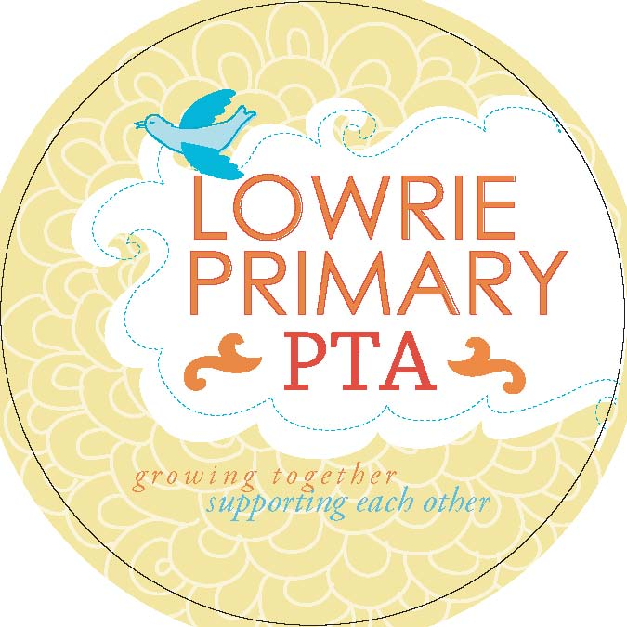 | Funding Proposal

The Lowrie PTA Budget Committee will soon meet to develop the budget for fiscal year 2014-2015 school year. The first step in this process is to solicit ideas and requests from teachers, staff, committees and parents. Once all requests are submitted, the Committee will meet to determine which projects are economically feasible. Costs must be as accurate as possible in order to be included in the proposed budget. The Budget Committee will make recommendations and present a draft budget upon which the Lowrie PTA membership will vote.

The timeline to be used for the process is as follows:

- April 11, 2014: All budget requests due
- May 2014: General meeting preliminary vote on proposed budget (Date to be announced)

Please complete this form and email to Josh Daglish, at jdalglish@gmail.com or deliver to the Lowrie PTA mailbox in the office at your earliest convenience, but NO LATER THAN APRIL 11, 2014 .

Project description and purpose
Project title:
Priority program area:  - Student Enrichment (in music, arts, technology, science, math, engineering, and wellness)  - Teacher and Classroom Support  - Family Engagement | - Community Building  - Service Opportunities
Estimated Amount:

Grade level (if applicable):

Ongoing or one time project:

Submitted by:

Email/phone:

Who will benefit

Any related projects

Staff/volunteers hours needed (if any)

Cost, timeline and resource needs

Additional comments

Proposals are due Friday April 11, 2014. Send completed forms to:

Josh Daglish, Lowire PTA Treasurer

Email: jdaglish@gmail.com

