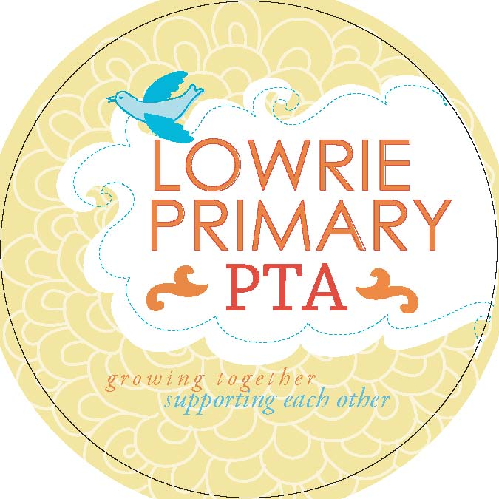 | Funding Proposal

Project title:
Priority program area:  - Student Enrichment  - Teacher and Classroom Support  - Family Engagement |  | - Community Building  - Service Opportunities
Amount:

Grade level:

Expected start date: Expected end date:

Submitted by:

Purpose

Target Audience

Expected Impacts

Any related projects

Staff/volunteers hours needed (if any)

Cost and resource needs

Additional comments

